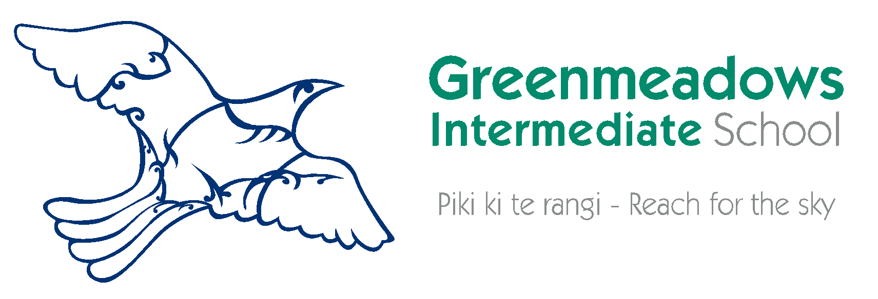

Parent/Caregiver Permissions & Agreements 2022

By law, schools are required to get permission from parents/caregivers for a number of things these days! Please note the Student Use of Digital Technology Agreement also needs to be signed but it is a separate document.

Please read the attached information carefully, sign permissions/agreements as appropriate and return with your enrolment form.

Publication of Student Images and Work (see below to read the policy)
I have read the school information regarding the publication of student images and work. I give permission for Greenmeadows Intermediate School to publish my child’s images and work for the following reasons:
- for educational purposes,
- to share the results of learning with the community
- to promote the school in a positive way.

Signed: _________________________ Signed: ________________________________
Parent/Caregiver Student

Sharing of Information
I also give permission for the information contained in this enrolment form and students attainment records to be made available to other educational and support agencies.

Signature of Parent/Caregiver: ____________________________ Date: ________________

Attendance & Uniform Agreement
I undertake to see that .................................................................... attends school regularly, wears correct uniform, follows the school rules and regulations as set by the Board of Trustees.

Signature of Parent/Caregiver: ____________________________ Date: _________________

PUBLICATION OF STUDENT IMAGES AND WORK

WHY IS IT IMPORTANT THAT THE SCHOOL HAS AUTHORISATION TO PUBLISH STUDENT IMAGES AND WORK?

From time to time, we publish material for educational purposes, to share the results of learning within the school community, and to promote the school within the wider community. This could be in the school newsletter, local paper, educational publications, or on the school website or Facebook page. This material could include examples of students’ schoolwork and/or images of students and groups of students involved in school activities.

GUIDELINES:
- Copyright
The school will not publish a student’s image or work if a parent has not given us signed permission to do so. Parents do need to inform the school if their circumstances change and they no longer wish their child’s image or work to be published.
- Privacy
The school acknowledges that it cannot control who accesses the websites on which students’ images or material is published or the copying, by visitors to these websites, of images of the students and their work. Students’ surnames, home addresses, and telephone numbers will not be available on the website.
- School management
The school will not publish material that may defame anyone, be objectionable from a human rights point of view, be obscene, or infringe the copyright of third parties. All the student material published will be subject to an editing process, which will include the correction of spelling and grammatical errors.
- Permission sought by the school (refer to Parent/Caregiver Permissions)
The permission the school seeks is:
  - Authorisation to publish the student’s personal image or work as required by the Privacy Act, and
  - A licence to publish any copyright work of the student.

- Enquiries
The school has a designated privacy officer (the Principal) who is available to answer any enquiries from parents or students about the operation of the school’s policy for the publication of student images and work.
- Disputes
The school has a procedure to resolve complaints or other disputes. This procedure is contained in Procedures for Complaints.

